**Level 1 Hard materials Technology**

**Chair Design**

**6 credits**

**Achievement standard 1.20 (AS 91057)**

Implement basic procedures using resistant materials to make a specified product

|  |  |  |
| --- | --- | --- |
| Achievement | Achievement with Merit | Achievement with Excellence |
| Implement basic procedures using resistant materials to make a specified product. | Skilfully implement basic procedures using resistant materials to make a specified product. | Efficiently implement basic procedures using resistant materials to make a specified product. |

**Authenticity Statement**

Authenticity means that all work submitted is YOUR OWN. All resources have been acknowledge, including books, verdal conversations, internet sites etc….

I _______________________________ declare that the work submitted is my own and all resources have been acknowledged.

Signiture ________________________ Date __________________

**Teacher Verification**

I declare that the work attched is to the best of my knowledge that of the student named above.

**Teacher Name;** Mr J woodford

Signiture ________________________ Date __________________

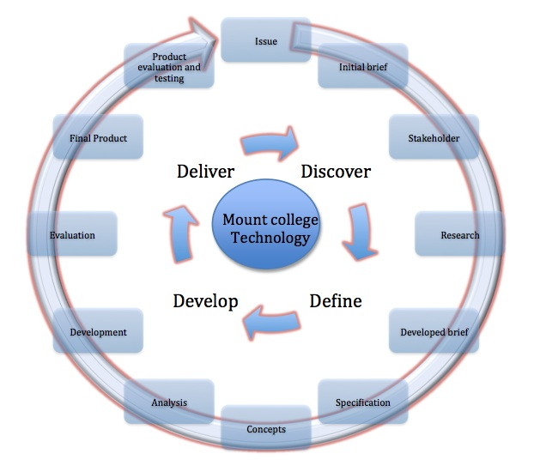

Introduction

This assessment activity requires you to make a wooden chair and carry out a range of appropriate tests to demonstrate that the product meets specifications and is finished to a high standard.

You will be assessed on:

* the extent to which the chair meets specifications
* the manner in which you apply techniques and testing procedures that comply with relevant safety regulations.
* Your independence, as well as your accuracy and efficiency (which includes how well you economise time, effort, and materials) will be taken into account.

You will also need to show following range of techniques and testing procedures:

* one or more measuring/marking out techniques, such as rulers, tape measures, and marking pencils
* one or more sizing/shaping/forming techniques, such as gluing, clamping, stapling, nailing, screwing, bolting (these techniques could include the use of equipment such as lathes, saws, chisels, files, and milling equipment)
* one or more joining/assembly techniques, such as gluing, clamping, stapling, nailing, bolting, and using a jig
* one or more finishing techniques such as painting, oiling, staining, buffing, and polishing.
* before gluing, checking that pieces fit together accurately
* measuring checks to make sure the product is square (if specified)
* visual checks to make sure the product has a smooth finish.

You will have 9 weeks to complete this task, your final hand in date is

_______________________­­__________

Design Brief

You are to design a chair that will be able to be used for a formal dining occasion or at a work desk. This will give you your own personal, ergonomically designed seat that will be easily identifiable so that it will be for your use only.

Specifications/ Constraints

Your final product must;

1, Be made to the correct size for its function

2, Have a high quality finish

3, Made using leg and rail construction

4, Cost no more than $50 to construct

5, Function for its intended use

Tools;

As you use each tool listed below explain what it is used for and the most effective way of using it.

Metal ruler

Square

Marking guage

Craft knife

Bench hook

Vice

Tennon saw

Coping saw

Scroll saw

Plane

Hand drill

Palm sander

Belt sander

Domino Machine

Construction techniques;

There are many different types of wooden joints that can be used in the construction of your chair;

|  |  |  |
| --- | --- | --- |
| Name of joint | Drawing of joint | Strength |
| Butt Joint |  |  |
| Dowell joint |  |  |
| Bridle joint |  |  |
| Mortise and tenon joint |  |  |

Some of these joints have mechanical strength, what is this ________________________________________________________

Which joints would have mechanical stregnth?

Chair construction

Below shows a example of the chair frame that is going to be made, what types of joints scould be used in the construction of your chair.

Types of finishes

Explain why finishes need to be applied to a product?

Give an explanation of each of the below finishes and how it is applied ?

1. Paint

2. Varnish

3. Oil

4. Wax

5. Stain

Before any finish can be applied you must prepare the surface explain below how to apply a finish of paint and varnish to wood.

Varnish Paint

Anthropometrics and Ergonomics

**Anthropometrics** is the study of the sizes of people in relation to products.

For example, chairs used in schools need to be suitable for the average size of pupils in the school

**Ergonomics** is the relationship between people and the products, which they use. Anthropometric data is used to help design products to meet ergonomic needs. Ergonomics how comfortable that chairs in a school are.

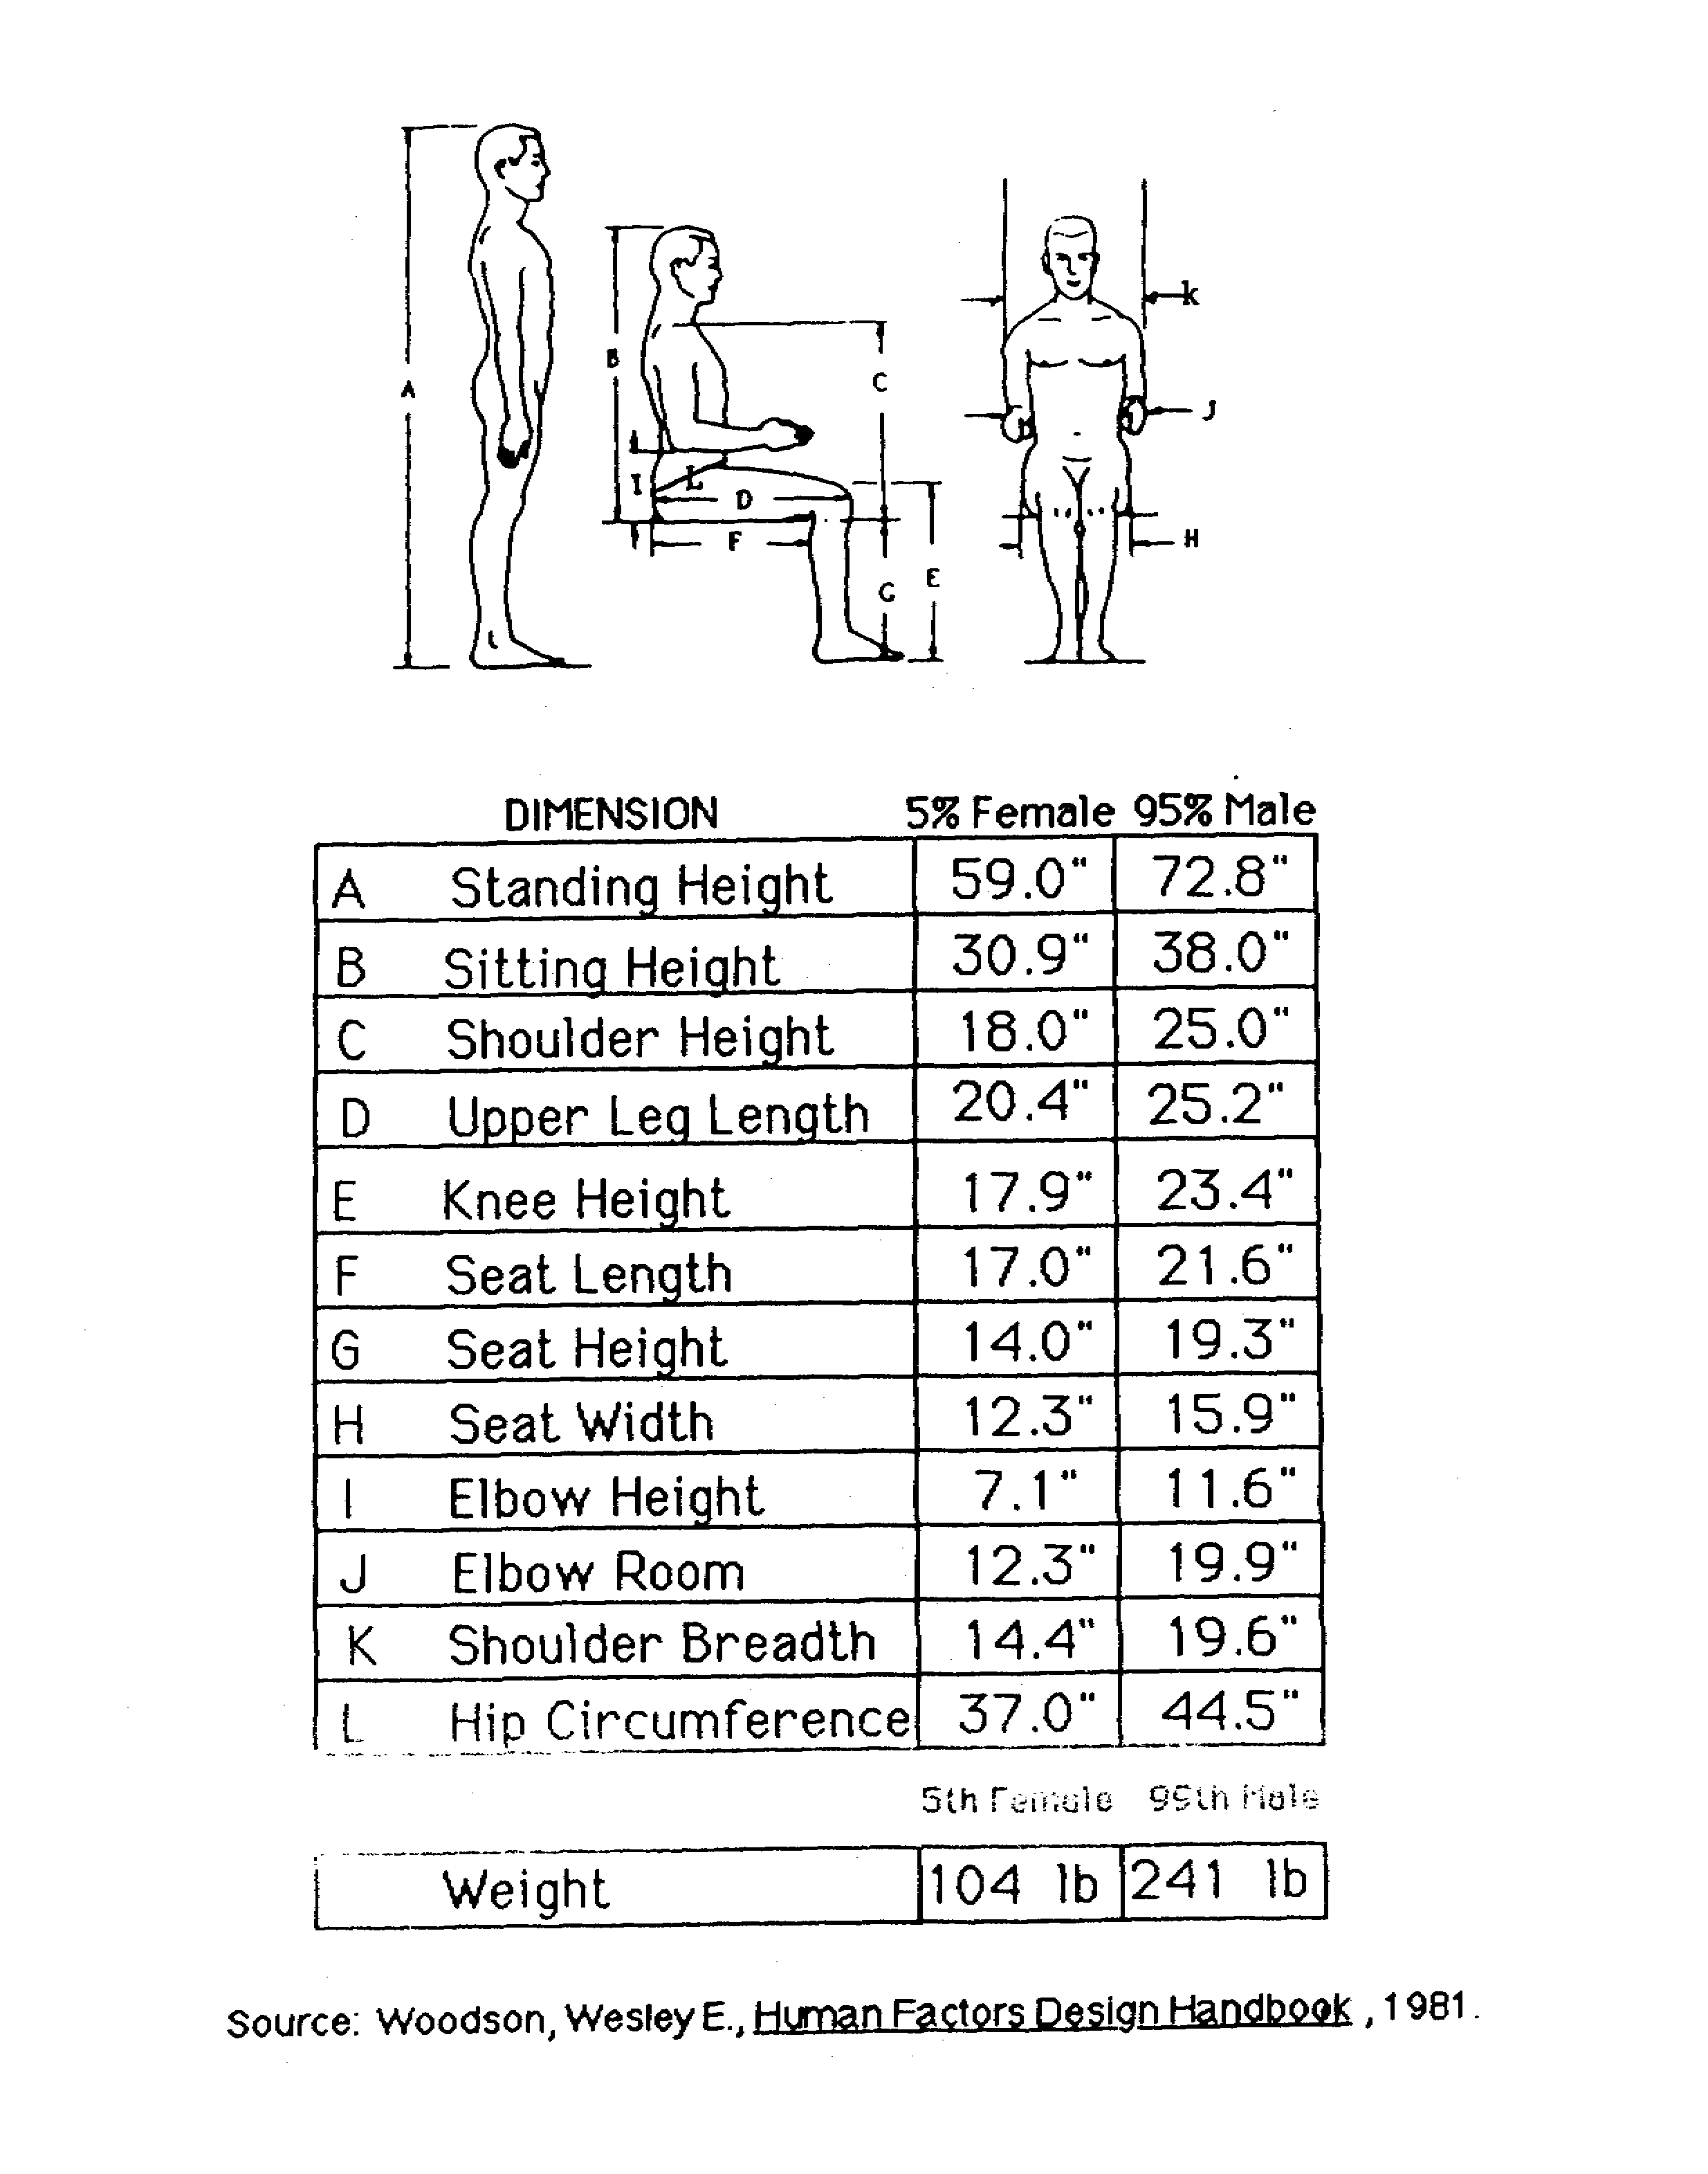



The picture above shows some of the key measurements that are needed when designing a chair,

Which measurements will be key to deisgning a chair that is ergonomically comfortable for you?

Gather some data that could be used to ensure your chair is made ergonomically excellent

Product Analysis

Look at the back style of each of these chairs and write brief disctiptive words and thoughts about what you think of each of these.

Initial thoughts

Below shows the basic shape of your chair, however you are to design the back of your chair and shape the legs. Around the chair sketch some ideas that could be used.

Development of Idea

Using your initial thoughts develop a final solution to use as the back of your chair and shape the legs. Use sketches and models which explain the following.

* How the design works.  
* Exploded views of different parts

Working drawings

Below shows a simple working drawing of your chair frame, add your chosen back design ensuring that the measurements are accurate with the rest of the drawing and show the shape of the legs.

Cutting list

|  |  |  |  |
| --- | --- | --- | --- |
| Part | Size,  width, depth, height  (mm) | Quantity | Material |
| Front legs |  |  |  |
| Back legs |  |  |  |
| Side rails |  |  |  |
| Front rail |  |  |  |
| Back rail |  |  |  |
| Back supports |  |  |  |
|  |  |  |  |
|  |  |  |  |
| Seat |  |  |  |

Construction Plan

Flowchart of construction

Produce a flowchart showing how you plan to construct your chair, (continue to the following page if not enough room)

Health and Safety

Risk assessment of workshop;

|  |  |  |
| --- | --- | --- |
| Hazards | Who may be harmed and how | Actions that need to be taken to prevent accidents |
|  |  |  |
|  |  |  |
|  |  |  |
|  |  |  |
|  |  |  |
|  |  |  |

Construction review

Use your flowchart of construction to review each step of construction as you move forward with the construction of your chair.

|  |  |  |
| --- | --- | --- |
| Stage of construction | Tools used | Explanation of task, problems that occurred, fixes |
|  |  |  |
|  |  |  |
|  |  |  |
|  |  |  |
|  |  |  |
|  |  |  |
|  |  |  |
|  |  |  |
|  |  |  |
|  |  |  |

Photo of final solution

Evaluation

Reflect how successful has your design been; How well does your product fulfil your design brief and specification? What could you have improved or developed further to better your product? What do perspective users think about it?

………………………………………………………………………………………………………………………………………………………………………………………………………………………………………………………..

………………………………………………………………………………………………………………………………………………………………………………………………………………………………………………………………………………………………………………………………………………………………………………………

………………………………………………………………………………………………………………………………………………………………………………………………………………………………………………………..

………………………………………………………………………………………………………………………………………………………………………………………………………………………………………………………..

………………………………………………………………………………………………………………………………………………………………………………………………………………………………………………………………………………………………………………………………………………………………………………………

………………………………………………………………………………………………………………………………………………………………………………………………………………………………………………………..

………………………………………………………………………………………………………………………………………………………………………………………………………………………………………………………..

………………………………………………………………………………………………………………………………………………………………………………………………………………………………………………………..

|  |  |  |
| --- | --- | --- |
| Evidence/Judgements for Achievement | Evidence/Judgements for Achievement with Merit | Evidence/Judgements for Achievement with Excellence |
| With some guidance, the student has followed a set of techniques to make a product that meets specifications, and undertaken a range of appropriate tests to demonstrate the product meets specifications.  The student:   * used one or more techniques and tests from each of the following categories: * measuring/marking out – the student marked out components with guidance * sizing/shaping/forming * joining/assembly – the joints show some faults and lack of precision (most joints meet the tolerances noted in the plan) * finishing/detailing – the rimu is polished to a useable finish and oiled * carried out a range of appropriate tests to demonstrate the product meets specifications, for example, performance testing (such as testing of joints), fitting (such as mating of joints before gluing), visual checks (such as checking straightness of edges, alignment of legs, right angles at corners, and surface quality) * applied techniques to comply with relevant health and safety regulations. The student has followed classroom rules such as: * ensure sleeves rolled up when using any machines * wear safety glasses when machining * ensure all machine guards are fitted and working before commencing machining * ensure machine is turned off before using any measuring instruments. | The student has followed a set of techniques to make a product that meets specifications, showing independence and accuracy in the execution of the techniques and tests.  The student:   * used one or more techniques from each of the following categories: * measuring/marking out * sizing/shaping/forming * joining/assembly * finishing/detailing * carried out a range of appropriate tests to demonstrate the product meets specifications, for example, performance testing (such as testing of joints), fitting (such as mating of joints before gluing), visual checks (such as checking straightness of edges, alignment of legs, right angles at corners, and surface quality) * applied techniques to comply with relevant health and safety regulations * followed the step-by-step plan independently (needing minimal support from the teacher to do so) * made joints without faults (showing precision and accuracy in the use of the workshop equipment) * visually checked the joints against the specifications * achieved a quality finish (the rimu is highly polished and oiled, with no machining blemishes or glue apparent). | The student has independently and accurately followed a set of techniques to make a product that meets specifications, undertaking techniques and tests in a manner that economises time, effort, and materials.  The student:   * used one or more techniques from each of the following categories: * measuring/marking out * sizing/shaping/forming * joining/assembly * finishing/detailing * carried out a range of appropriate tests to demonstrate the product meets specifications, for example, performance testing (such as testing of joints), fitting (such as mating of joints before gluing), visual checks (such as checking straightness of edges, alignment of legs, right angles at corners, and surface quality) * applied techniques to comply with relevant health and safety regulations * followed the step-by-step plan independently * implemented the techniques in a straightforward manner, following the specifications * visually checked that the legs were straight and in the same plane * constructed accurate and well-fitted joints, not using trial and error (for example, in a leg and rail joint the leg fits to the rail within the tolerances specified in the plan) * spent little or no time repeating techniques to achieve acceptable accuracy or in redoing steps because the incorrect technique was used in the first place * achieved a quality finish (the rimu is highly polished and oiled with no machining blemishes or glue evident) * finished in the agreed timeframe * cut the pieces as prescribed in the plan with no wastage. |

Assessment Schedule; AS91057

**Implement basic procedures using resistant materials to make a specified product**